**User's Manual**

**Survey System Anywhere**

**Lizard League Software**

**System Requirements**

Survey Software Anywhere operates within the Microsoft Windows environment and does not require any specialized hardware outside that environment. We do recommend the user has installed Microsoft Windows XP or later and the following for the most efficient interaction with your system:

* 1 gigahertz (GHz) or faster 32-bit (x86) or 64-bit (x64) processor
* 1 gigabyte (GB) RAM (32-bit) or 2 GB RAM (64-bit)
* 1 GB available hard disk space (32-bit)
* DirectX 9 graphics device with WDDM 1.0 or higher driver

Survey Software Anywhere requires Java to run. We recommend at a minimum version 1.4.0 or greater. I you do not already have Java installed on your computer it can be downloaded at <http://java.sun.com>.

**Installation**

Download the Survey Software Anywhere zip file from the following location:

<https://github.com/UIS-CSC478-project/survey-software/tree/master/InstallAndInstructions>

* Extract the SurveySoftwareAnywhere.zip to a folder on your machine where you have write permissions. If the permissions are not correct, you will receive errors when the software tries to access its database.
* To start using Survey Software Anywhere, double-click on the file SurveySoftwareAnywhere.jar.
* Included in the zip file is a Users' Manual, the License file, and a ReadMe. Review these documents before first use of Survey Software Anywhere.

**Getting Started**

After downloading and installing the software open it by clicking on the SurveySoftwareAnywhere.jar found in the folder where the zip file was extracted. A box will appear on the screen with three option buttons: Create Survey, Look up Survey, and Quit. This is the main menu that will be referenced throughout rest of this document.

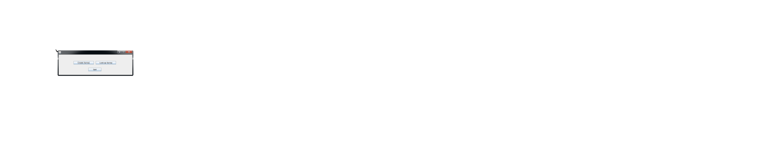

Clicking on the Create survey button will open a new window used to begin a survey creation. Clicking on the Look up Survey button opens a new window allowing a user to find previously created surveys. The quit button is used when the user is finished and wishes to quit to the software.

**Creating a Survey**

Clicking the create survey button opens the following window:

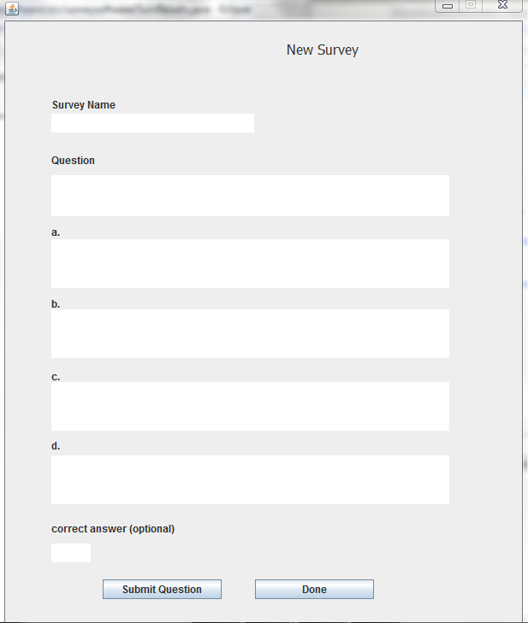

**Adding a question**

With the first question enter the Survey Name in the text box. This name will be assigned to all the questions created for this title until it’s changed. The survey creator allows a user to create a question and then 4 possible answers signified by “a” through “d.” A text box is available if the user wishes to indicate optionally what the correct answer would be. After finishing the entry for the first question and the user is ready to move to the next question, click the “Submit Question” button. The question and associated information will be added to the originally given title. The window will remain open, and the question text boxes will be emptied, prepared for the next question entry. If the user is finished with the survey creation, click the “Done” button. The user is brought back to the main menu.

**Look up a Survey**

Clicking the “Look up Survey” button from the main window opens the following window:

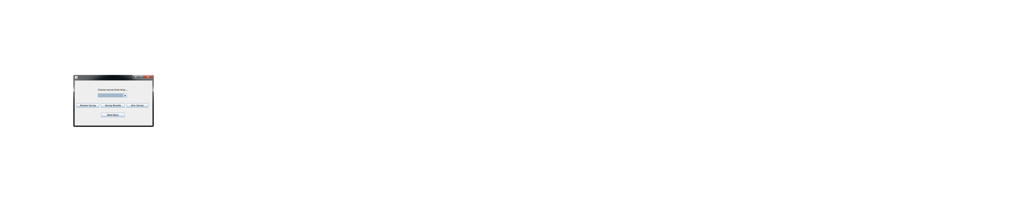

From the drop-down box select an existing survey. After the selection has been made there are four survey choice buttons: Review Survey, Survey Results, Give Survey, and Main Menu. Clicking the Review Survey button allows the user to access the chosen survey and review the questions and answer choices that had been created. Clicking the Give Survey button initializes the chosen survey to be given to survey takers. If the user is finished with reviewing and giving a survey, click the main menu, and the user is taken back to the main menu.

**Review Survey**

After the survey name is selected in the drop-down box, click the button Review Survey. The window that will open will show the entire survey and the possible results.

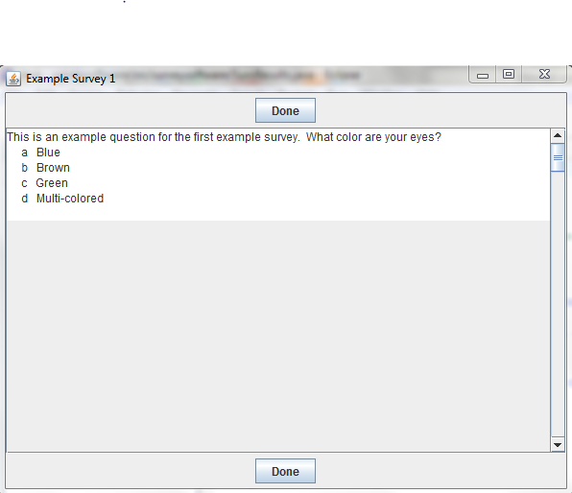

There are two Done buttons available. One at the top of the window and one at the bottom. Click either Done button to return to the main menu.

**Give Survey**

After the survey name is selected in the drop-down box, click the button Give Survey. The window that will open will show the entire survey and the possible results, and have a text field where you can enter an answer. For each question, enter the letter that corresponds to the possible answers. Every question must be answered.

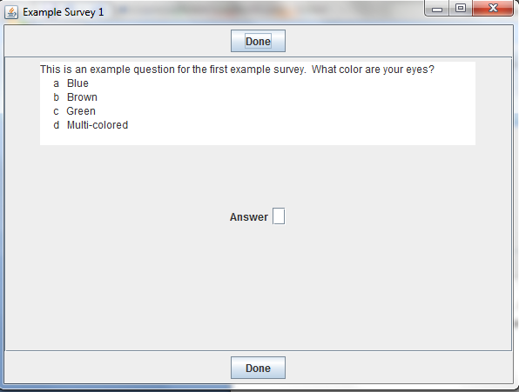

There are two Done buttons available. One at the top of the window and one at the bottom. When the survey has been completed, click either Done button to return to the main menu.

A survey can be given many times. When another person is ready to take the survey, click the Look up Survey button again, select the survey from the drop-down, and click Give Survey.

**Survey Results**

After the survey name is selected in the drop-down box, click the button Survey Results. The window that will open will show the entire survey and the letters that corresponded to answers. Next to the letters will be a column that lists how many users chose that letter. In another column to the right will be the percentage of users that chose that letter.

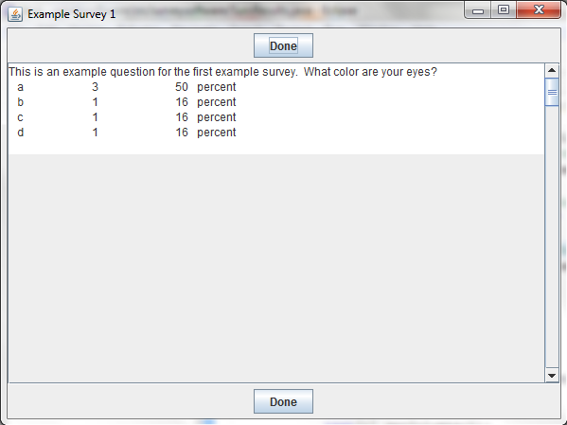

There are two Done buttons available. One at the top of the window and one at the bottom. When finished reviewing the results, click either Done button to return to the main menu.